**El banco MANAGEMENT**

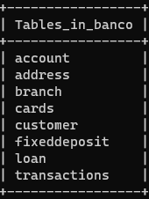

**While creating new accont the branch should be alredy set**

**User sends name >gets saved> addressIDgeneratedByDartabase > with reference of the id genbyDB we save address fields in address table**

**Account address branch customer fixeddeposit loan cards**

AVERAGE MONTHLY BALANCE OTHERWISE INCUR CHARGES

EXPORT THE BALANCESHEET

GIVE OUT LOAN

CALCULATE LOAN

CHEQUE BOOK

**EL BANCO USEREND**

NET BANKING[DIFFERENT MODULE]

SCAN QR CODE TO PAY

GENERATE QR